Physics 440 - Assignment 1

Kaya Baber

2/29/16

(1)

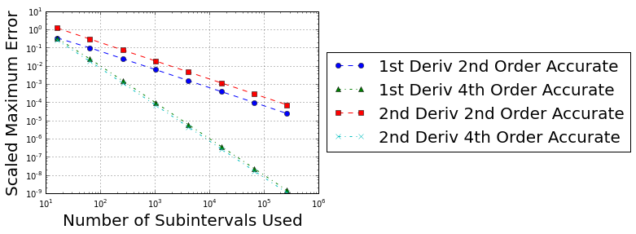Log-log plot of the scaled maximum error of 4 central-difference differentiators as a function of the number of subintervals used to calculate the derivatives. Sin(2\*pi\*x) between [0,1] was used as the test function to differentiate and take error between the expected and computed derivatives.   
The 2nd order methods needed 100 intervals to reach 10% error and 1000 to reach 1%.   
The 4th order methods needed 30 intervals to reach 10% error and 100 intervals to reach 1%.

(2)

